**Writer’s Journal—Expectations**

* Journals must be brought to class EVERY day.
* 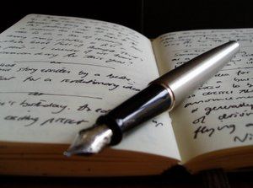In order to receive credit for an entry, it must be at least ½ page in length. The only writings in the Writer’s Journal are to be the entries provided in class and Mind Benders.
* You must complete every entry: if absent, it is expected that you make-up any/all entry missed by getting the topic from a classmate/class website. (Write in your journal EVERY day.)
* If you do NOT want me to read an entry, fold the piece of paper over. I will not read it.
* As you write in class, cover your journal if you do not want me to read it.
* Journals will be collected/submitted periodically throughout the semester in order to be graded; therefore, although they are not expected to be polished works, they must be legible. I don’t expect perfect grammar or spelling because they are not polished pieces. ☺